

|  |
| --- |
| **FUNCTIONAL REQUIREMENTS**  Product Name : opencart(Frontend) |
|  |

Prepared by: Chenna Basava

Date: April, 2024

Overview

OpenCart is a free e-commerce platform for online stores. It's great for both experienced web developers and new business owners starting online. OpenCart offers many features for easy customization, helping your online shop reach its full potential.

Requirements

To run OpenCart successfully, you need a few technical things. First, create a web server to make your store visible online. You can easily buy a domain name and hosting service at an affordable price. When choosing a hosting service, make sure it meets these server requirements:

PHP 5.4

jQuery 2.1.1

JavaScript

Database (MySQL is recommended)

Web Server (Apache is recommended)

Opencart Frontend

This document is an introduction to the default store front in OpenCart. It shows how customers see and use the store.

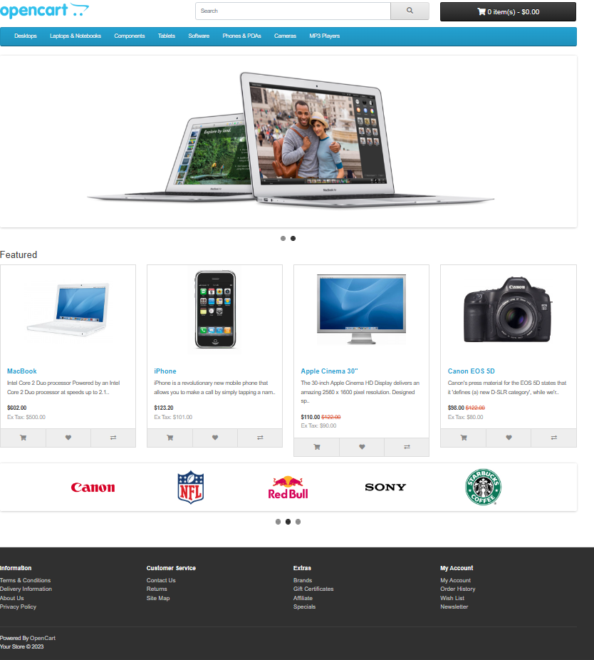

The products you see are part of the sample data in OpenCart. You can easily delete them and add your own products to the shop later..

Navigating the Shop

The default theme in OpenCart makes it easy for customers to navigate a shop's products.

Home page

The home page is crucial for presentation, often being the first page customers see, especially if they come from a search engine. The homepage should be user-friendly, showcasing the shop's products.

To understand the store's front, start by looking at the OpenCart default homepage.

Header

The header will be located at the top of every page, is an important part of the site, not just the home page.

The header has the following navigation Options:

On the store's page, here are some important features:

-> Store Logo: Clicking it takes you back to the home page.

-> Currency Block: Lets you choose the currency based on your country for buying products.

->Shopping Cart: Shows items and total price. Click to view or checkout.

->Search Box: Helps find products in store categories.

->Links: Directs to Home, Wish List, My Account, Shopping Cart, and Checkout.

->Telephone: Displays the company's phone number.

->My Account: Register or log in here as a customer or user.

Top Menu

The top menu shows main product categories and is visible on every page.

Hovering clicking on a Parent category reveals sub-categories.

Clicking a category directs to its page with all products.

Slide Show

The slideshow on the homepage displays selected product banners that change over time. Clicking a banner directs to the featured product's page. The slideshow is exclusive to the homepage.

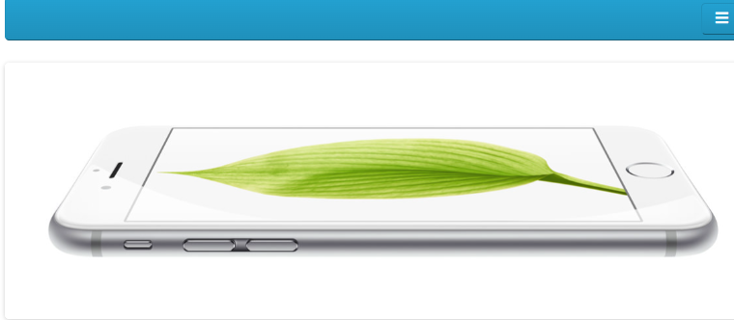

Featured Products

OpenCart allows featuring selected products of their choice on the homepage for special attraction.

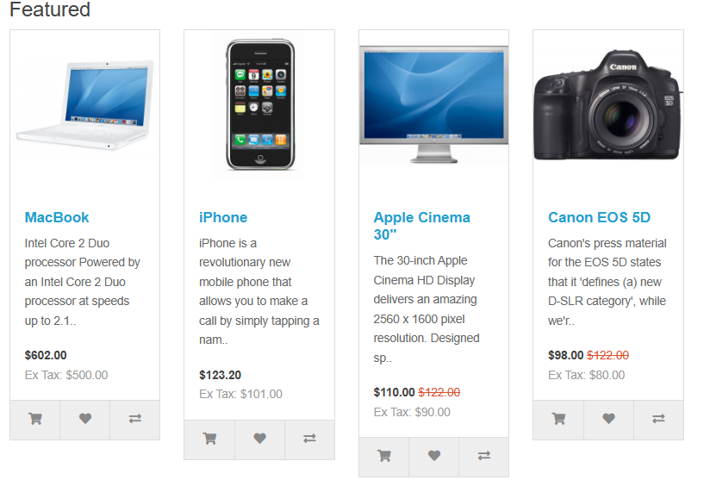

The featured section includes the product images, price and an option to add the product directly to the shopping cart.

Note:This feature is only applicable to home page.

Footer

The footer, at the bottom of every page, has various links for easy navigation.

It includes sections like

**Information:** “About us” , ”Delivery information”, ”Privacy policy” , “Terms and Conditions”

**Customer Service:** “Contact us” ,”Returns” , ”Site-map”.

**Extras**: “Brands”, “Gift Vouchers” ,“ Affiliates”,”Specials”.

**My Account:** Each with specific links such as About Us, Order history, Wishlist, and Newsletter. These help customers find relevant pages that don't fit elsewhere logically.

Product pages

The OpenCart default product page will follow the structural format seen below.

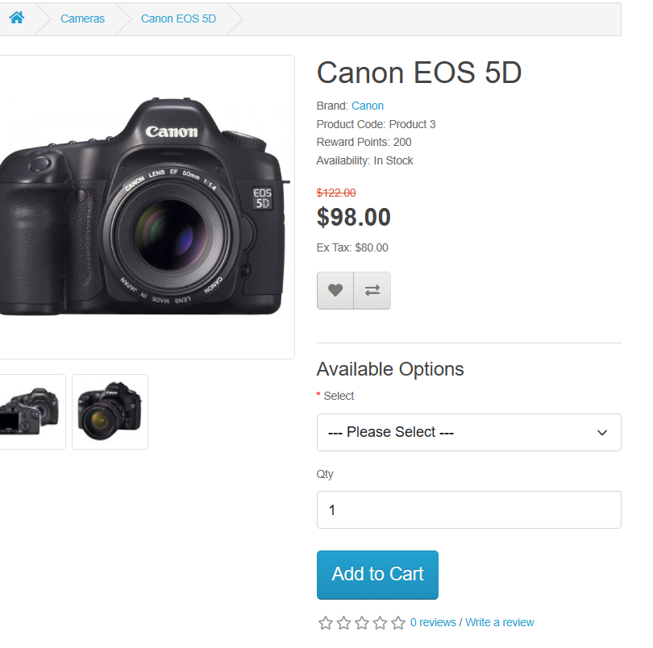

The product page has several sections:

**- Product Image**: Displayed under the title on the left, with alternate views below. Clicking expands the image for a closer look.

**- Product Details**: Shows product code, availability, and price next to the image.

**- Cart**: Allows customers to select quantity and add the product to cart, wish list, or for comparison.

**- Rating/Sharing**: Below the cart, customers can rate or share the product on social media.

**- Description Tab**: Provides a detailed product description under the main information.

**- Review Tab**: Allows customers to write a review for the product.

**Category Product Listings**

Category product listings help customers find similar products in the same category, making it easy to compare. You can access the category page by clicking on a parent category in the top menu or by selecting a category from the left-side category block on product pages.

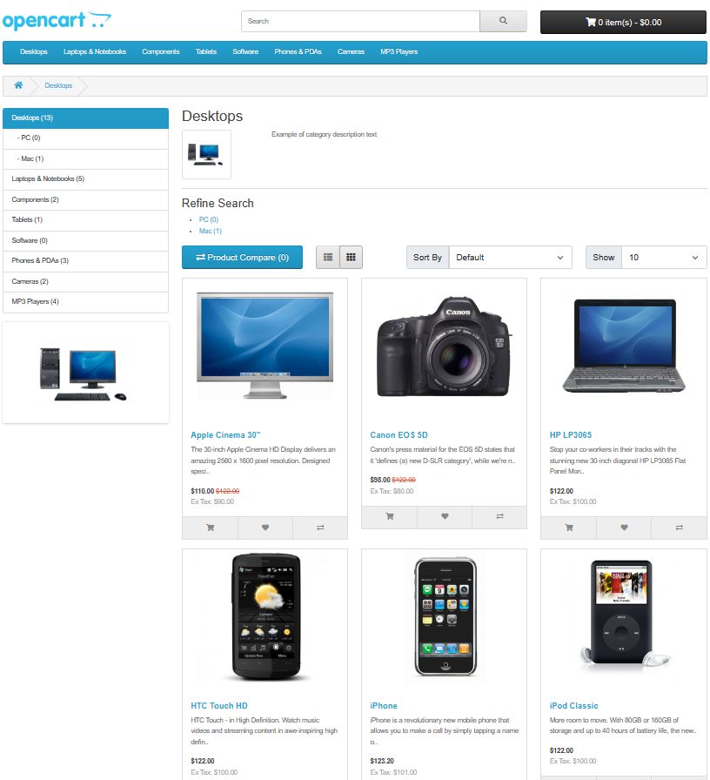

On the website, you can view products either in a list or grid. You can sort them by name, price, rating, or model. The number of products displayed can be changed from 15 to 100.

Each product in a category has its own space with an image, description, price, and an "Add to Cart" option.

**Product Compare**

You can also Compare" the products in terms of specifications, features, and prices of different products.

**Shopping Cart page**

Once a customer adds a product to the cart, they can access the shopping cart in the header under "Shopping Cart"

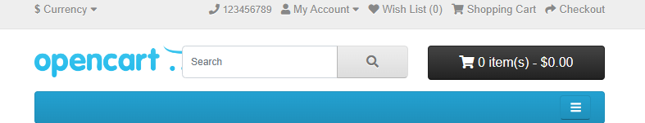



The shopping cart shows a summary of your selected products with details like image, product name, model, quantity, unit price, and total cost. You can add a coupon code or gift voucher, or estimate shipping and taxes before going to checkout. To go back to the homepage, use the "Continue Shopping" button..

Before buying, you choose to check out as a guest or log into your account. Guest checkout is quick and doesn't need a login. If you've shopped before, then you can login with your existing account details, if you are new customer then create account first.

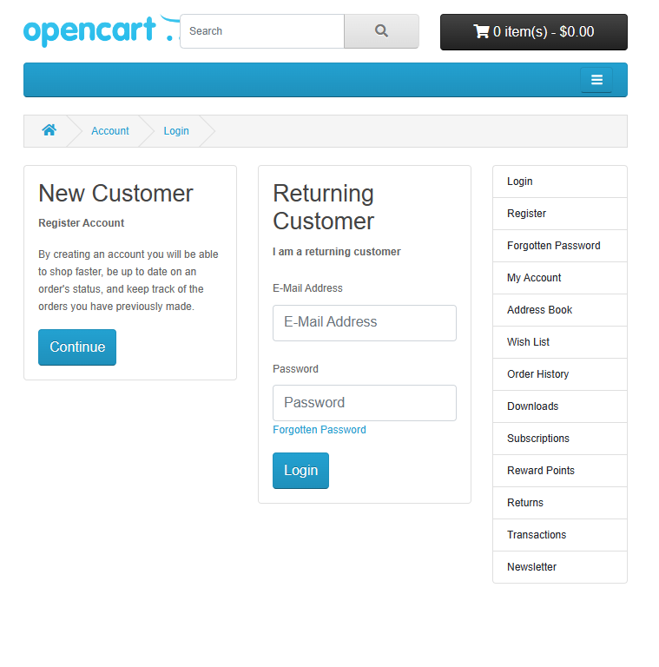

**CheckOut**

To buy something, go to checkout from your cart. Look for it in the header under the search box. Checkout has six steps:

1. **Step 1: Checkout Options**

- Log in, sign up, or choose guest checkout.

2. **Step 2: Billing Details**

- Fill in your name, email, phone, and address.

3. **Step 3: Delivery Details**

- If your delivery address is the same, check a box; if not, add the details.

4. **Step 4: Delivery Method**

- Pick a shipping method and add any comments.

5. **Step 5: Payment Method**

- Choose how to pay and add any comments.

6. **Step 6: Confirm Order**

- Check your order details, including what you're buying, how much, and the total cost with tax and shipping.